Project General Design
  - Protein and Supplements Website

Project Goal:
The goal of this project is to build a website that is available for all types of user, who are interested in buying the provided items and supplements available on it. It is aimed to help buyers find the best items that they are searching for.

The general design of the web pages will be as follows:
Viewed by PC:
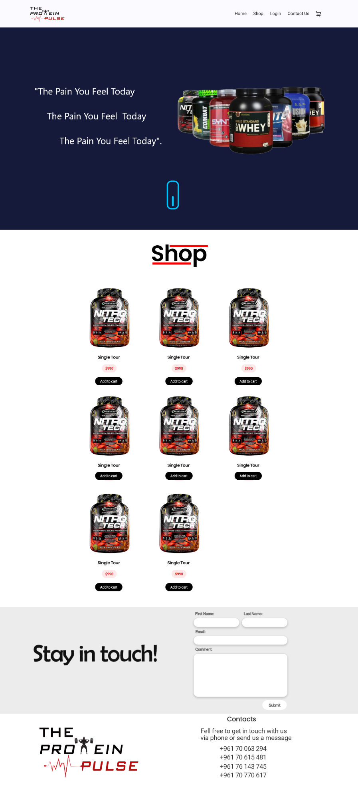
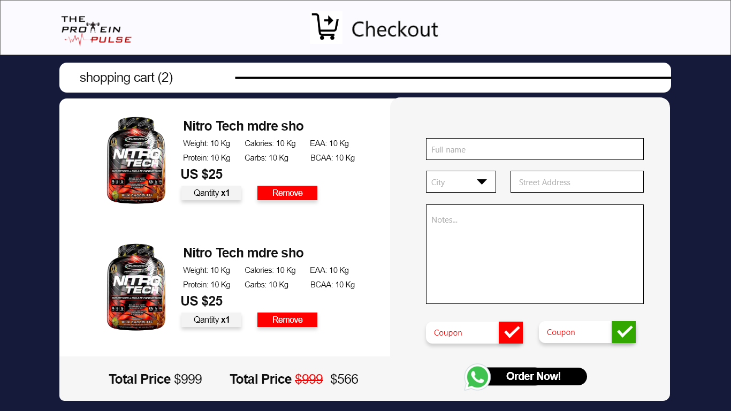

Viewed on mobile as:
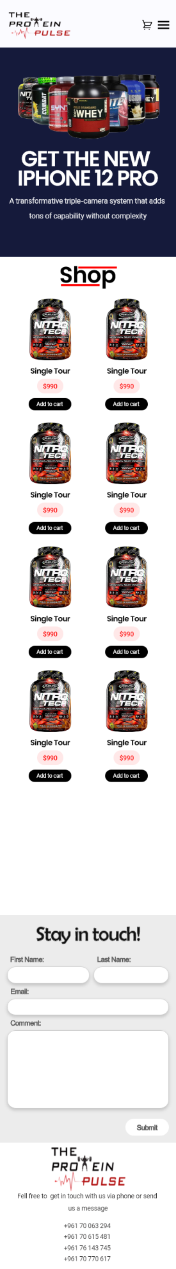
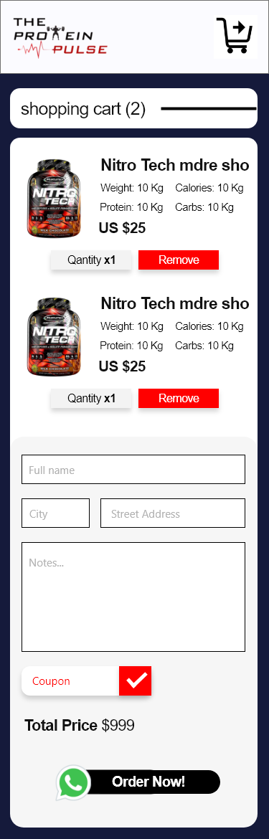

Will be able to be displayed on both phones and desktop screen, as shown above.
The design generally includes products, with additional information and prices, as well as a small form to fill in address information, and a WhatsApp logo that links to the WhatsApp business chat on which customers can also order.

